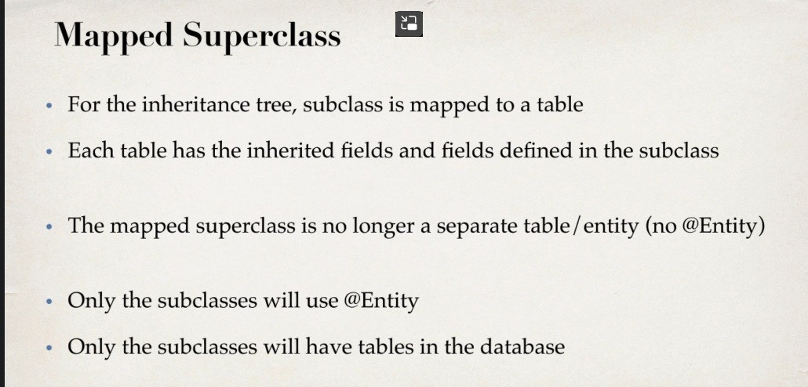

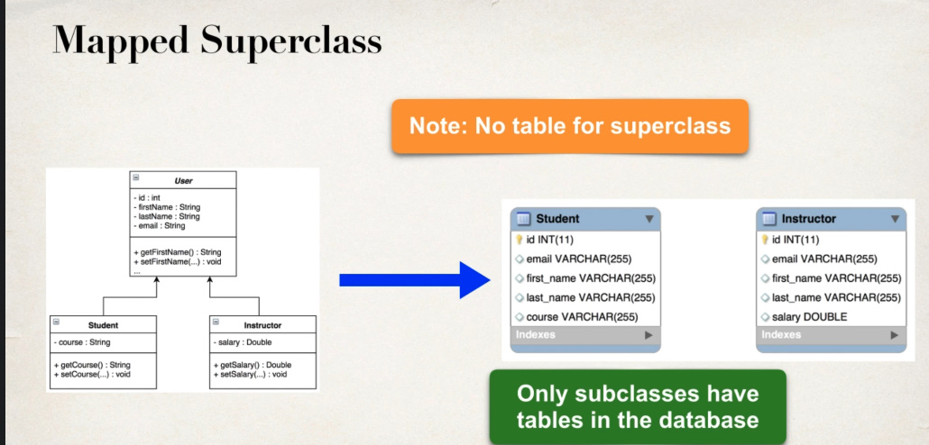

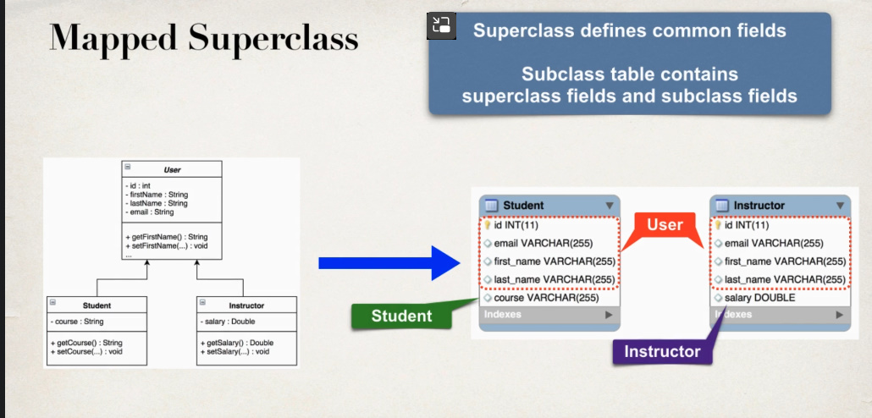

**Mapped Superclass Vs table per class**

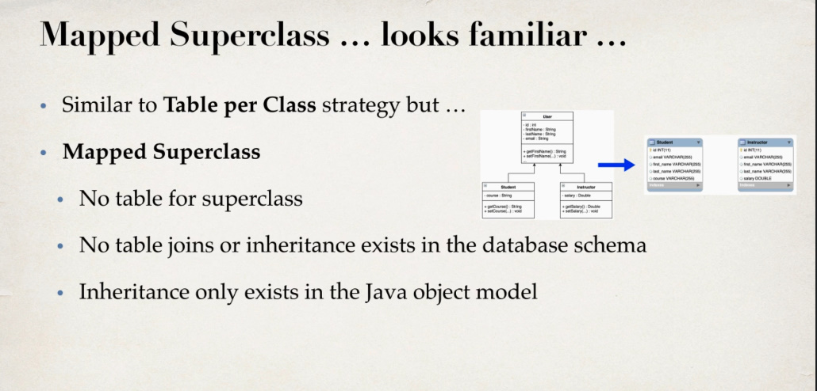

Deci superclass nu trebuie anotata cu @Table sau @Entity sau @Inheritance

Nu trebuie sa mai folosim SEQUENCE TABLE

**Project**

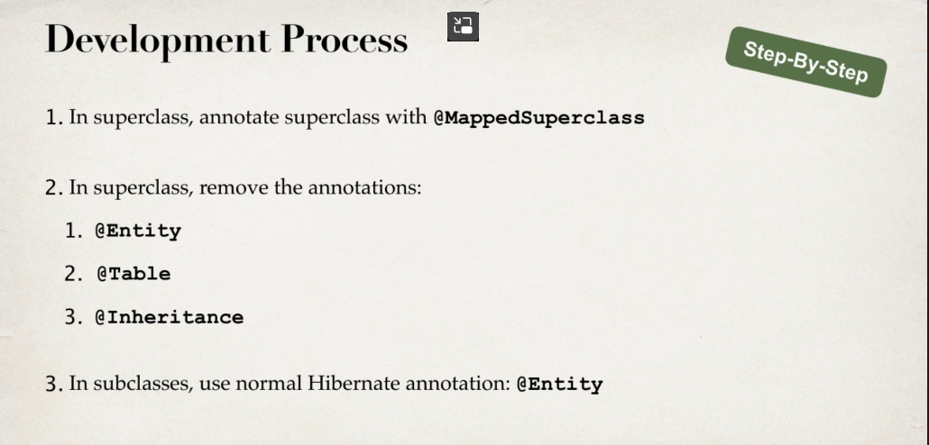

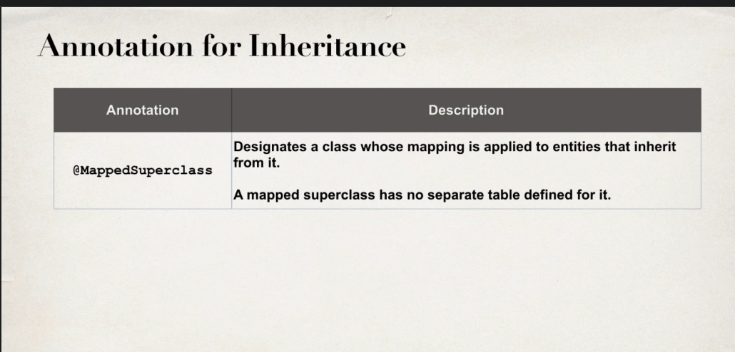

@MappedSuperclass spune pur si simplu ca clasa data este un simplu parinte la alte entity si gata

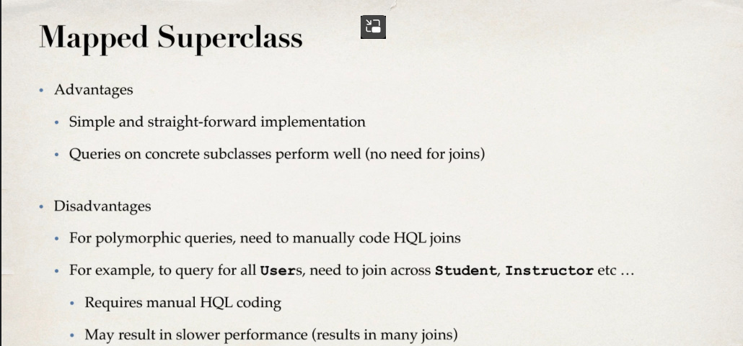

@MappedSuperclass  
  
@Getter  
@Setter  
@NoArgsConstructor  
@AllArgsConstructor  
@ToString  
public class User {  
 @Id  
 @GeneratedValue(strategy = GenerationType.*IDENTITY*)  
 @Column(name = "id")  
 private int id;  
 @Column(name = "first_name")  
 private String firstName;  
 @Column(name = "last_name")  
 private String lastName;  
 @Column(name = "email")  
 private String email;  
}

@Entity  
@Table(name = "student")  
  
@Getter  
@Setter  
@NoArgsConstructor  
@AllArgsConstructor  
@ToString  
public class Student extends User{  
 @Column(name = "course")  
 private String course;  
}

@Entity  
@Table(name = "instructor")  
  
@Getter  
@Setter  
@NoArgsConstructor  
@AllArgsConstructor  
@ToString  
public class Instructor extends User {  
 @Column(name = "salary")  
 private double salary;  
}